Practical 11
Problem Definition
Create a student management module to add, view, edit, delete, search and filter student records. All database operations must use MYSQL statements and clear success/failure messages.
Code:-
Db.php:-
<?php
mysqli_report(MYSQLI_REPORT_ERROR | MYSQLI_REPORT_STRICT);

$host = "localhost";
$username = "root";
$password = "";
$database = "studenthub";

try {
$conn = new mysqli($host, $username, $password, $database);
$conn->set_charset("utf8mb4");
} catch (mysqli_sql_exception $e) {
error_log($e->getMessage());
exit("Database connection failed. Check your database settings.");
}
?>
Index.php:-
<?php
require "db.php";

$message = "";
$messageType = "success";

// ADD OR DELETE STUDENT
if ($_SERVER["REQUEST_METHOD"] === "POST") {
$action = $_POST["action"] ?? "";

try {
// ADD STUDENT
if ($action === "add") {
$name = trim($_POST["name"] ?? "");
$email = trim($_POST["email"] ?? "");
$course = trim($_POST["course"] ?? "");
$semester = filter_var(
$_POST["semester"] ?? "",
FILTER_VALIDATE_INT
);

if (
$name === "" ||
!filter_var($email, FILTER_VALIDATE_EMAIL) ||
$course === "" ||
$semester === false ||
$semester < 1 ||
$semester > 12
) {
throw new InvalidArgumentException(
"Please enter valid student details."
);
}

$stmt = $conn->prepare(
"INSERT INTO students (name, email, course, semester)
VALUES (?, ?, ?, ?)"
);

$stmt->bind_param(
"sssi", $name, $email, $course, $semester
);

$stmt->execute();

$message = "Student added successfully!";
}

// DELETE STUDENT
elseif ($action === "delete") {
$id = filter_var(
$_POST["id"] ?? "",
FILTER_VALIDATE_INT
);

if (!$id || $id < 1) {
throw new InvalidArgumentException(
"Invalid student ID."
);
}

$stmt = $conn->prepare(
"DELETE FROM students WHERE student_id = ?"
);

$stmt->bind_param("i", $id);
$stmt->execute();

if ($stmt->affected_rows > 0) {
$message = "Student deleted successfully!";
} else {
$message = "Student not found.";
$messageType = "error";
}
}

} catch (InvalidArgumentException $e) {
$message = $e->getMessage();
$messageType = "error";

} catch (mysqli_sql_exception $e) {
error_log($e->getMessage());

if ($e->getCode() == 1062) {
$message = "This email already exists.";
} else {
$message = "Database operation failed. Please check your database.";
}

$messageType = "error";
}
}

// SEARCH AND FILTER STUDENTS
$search = trim($_GET["search"] ?? "");
$courseFilter = trim($_GET["course"] ?? "");

$searchTerm = "%" . $search . "%";

if ($courseFilter !== "") {
$stmt = $conn->prepare(
"SELECT student_id AS id, name, email, course, semester
FROM students
WHERE (name LIKE ? OR email LIKE ?)
AND course = ?
ORDER BY student_id DESC"
);

$stmt->bind_param(
"sss", $searchTerm, $searchTerm, $courseFilter
);

} else {
$stmt = $conn->prepare(
"SELECT student_id AS id, name, email, course, semester
FROM students
WHERE name LIKE ? OR email LIKE ?
ORDER BY student_id DESC"
);

$stmt->bind_param("ss", $searchTerm, $searchTerm);
}

$stmt->execute();
$result = $stmt->get_result();

// GET AVAILABLE COURSES
$courses = $conn->query(
"SELECT DISTINCT course FROM students ORDER BY course"
);

// SAFE HTML OUTPUT
function h($value) {
return htmlspecialchars(
(string)$value,
ENT_QUOTES,
"UTF-8"
);
}
?>

<!DOCTYPE html>
<html lang="en">
<head>
<meta charset="UTF-8">

<meta name="viewport"
content="width=device-width, initial-scale=1.0">

<title>StudentHub - Student Management</title>

<style>
* {
box-sizing: border-box;
}

body {
font-family: Arial, sans-serif;
background: #f0f3f8;
margin: 0;
padding: 16px;
color: #222;
}

.container {
max-width: 1300px;
margin: auto;
background: white;
padding: 32px;
border-radius: 12px;
min-height: 100vh;
}

h1, h2 {
text-align: center;
color: #2055a5;
}

h1 {
font-size: 38px;
margin: 25px 0;
}

h2 {
font-size: 28px;
margin-top: 28px;
}

input, select {
padding: 14px;
border: 1px solid #aaa;
border-radius: 3px;
font-size: 15px;
}

.add-form input,
.add-form select {
width: 100%;
margin: 6px 0;
}

button, .home-btn, .edit-btn {
display: inline-block;
padding: 12px 15px;
border: none;
border-radius: 5px;
cursor: pointer;
text-decoration: none;
font-size: 16px;
}

.home-btn {
background: #555;
color: white;
}

.add-btn {
background: #198754;
color: white;
margin-top: 6px;
}

.edit-btn {
background: #0d6efd;
color: white;
}

.delete-btn {
background: #dc3545;
color: white;
}

button:hover, .edit-btn:hover, .home-btn:hover {
opacity: 0.85;
}

.message {
padding: 15px;
margin: 20px 0;
border-radius: 5px;
font-size: 17px;
}

.success {
background: #d1e7dd;
color: #0f5132;
}

.error {
background: #f8d7da;
color: #842029;
}

.search-form {
display: flex;
flex-wrap: wrap;
align-items: center;
gap: 10px;
margin: 20px 0;
}

.search-form input {
flex: 1;
min-width: 200px;
}

.search-form button {
background: #eee;
color: #222;
}

.clear-btn {
color: #663399;
padding: 10px;
}

.table-wrap {
width: 100%;
overflow-x: auto;
}

table {
width: 100%;
border-collapse: collapse;
margin-top: 20px;
}

th, td {
border: 1px solid #ddd;
padding: 14px 12px;
text-align: left;
}

th {
background: #2055a5;
color: white;
font-size: 17px;
}

td {
font-size: 16px;
}

tbody tr:hover {
background: #f4f7fc;
}

.actions {
white-space: nowrap;
}

.actions form {
display: inline;
}

@media (max-width: 600px) {
body {
padding: 8px;
}

.container {
padding: 15px;
}

h1 {
font-size: 26px;
}

h2 {
font-size: 22px;
}

.search-form {
flex-direction: column;
align-items: stretch;
}

.search-form input,
.search-form select,
.search-form button {
width: 100%;
}

th, td {
padding: 9px;
font-size: 14px;
}
}
</style>
</head>

<body>

<div class="container">

<a href="index.php" class="home-btn">Home</a>

<h1>StudentHub Management System</h1>

<?php if ($message !== ""): ?>
<div class="message <?= h($messageType) ?>" role="status">
<?= h($message) ?>
</div>
<?php endif; ?>

<!-- ADD STUDENT -->
<h2>Add Student</h2>

<form method="POST" action="index.php" class="add-form">

<input type="hidden" name="action" value="add">

<input
type="text"
name="name"
placeholder="Student Name"
maxlength="100"
required
>

<input
type="email"
name="email"
placeholder="Student Email"
maxlength="100"
required
>

<input
type="text"
name="course"
placeholder="Course (e.g. CSE)"
maxlength="50"
required
>

<input
type="number"
name="semester"
placeholder="Semester"
min="1"
max="12"
required
>

<button type="submit" class="add-btn">
Add Student
</button>

</form>

<!-- SEARCH AND FILTER -->
<h2>Search and Filter Students</h2>

<form method="GET" action="index.php" class="search-form">

<input
type="search"
name="search"
placeholder="Search name or email"
value="<?= h($search) ?>"
>

<select name="course">
<option value="">All Courses</option>

<?php while ($c = $courses->fetch_assoc()): ?>
<option
value="<?= h($c["course"]) ?>"
<?= $courseFilter === $c["course"]
? "selected" : "" ?>
>
<?= h($c["course"]) ?>
</option>
<?php endwhile; ?>

</select>

<button type="submit">Search / Filter</button>

<a href="index.php" class="clear-btn">Clear</a>

</form>

<!-- STUDENT RECORDS -->
<h2>Student Records</h2>

<div class="table-wrap">

<table>

<thead>
<tr>
<th>ID</th>
<th>Name</th>
<th>Email</th>
<th>Course</th>
<th>Semester</th>
<th>Actions</th>
</tr>
</thead>

<tbody>

<?php if ($result->num_rows > 0): ?>

<?php while ($student = $result->fetch_assoc()): ?>

<tr>
<td><?= h($student["id"]) ?></td>

<td><?= h($student["name"]) ?></td>

<td><?= h($student["email"]) ?></td>

<td><?= h($student["course"]) ?></td>

<td><?= h($student["semester"]) ?></td>

<td class="actions">

<a
href="edit.php?id=<?= h($student["id"]) ?>"
class="edit-btn"
>
Edit
</a>

<form
method="POST"
action="index.php"
onsubmit="return confirm('Are you sure you want to delete this student?');"
>

<input
type="hidden"
name="action"
value="delete"
>

<input
type="hidden"
name="id"
value="<?= h($student["id"]) ?>"
>

<button
type="submit"
class="delete-btn"
>
Delete
</button>

</form>

</td>
</tr>

<?php endwhile; ?>

<?php else: ?>

<tr>
<td colspan="6" style="text-align:center;">
No student records found.
</td>
</tr>

<?php endif; ?>

</tbody>

</table>

</div>

</div>

</body>
</html>
Screenshot:-
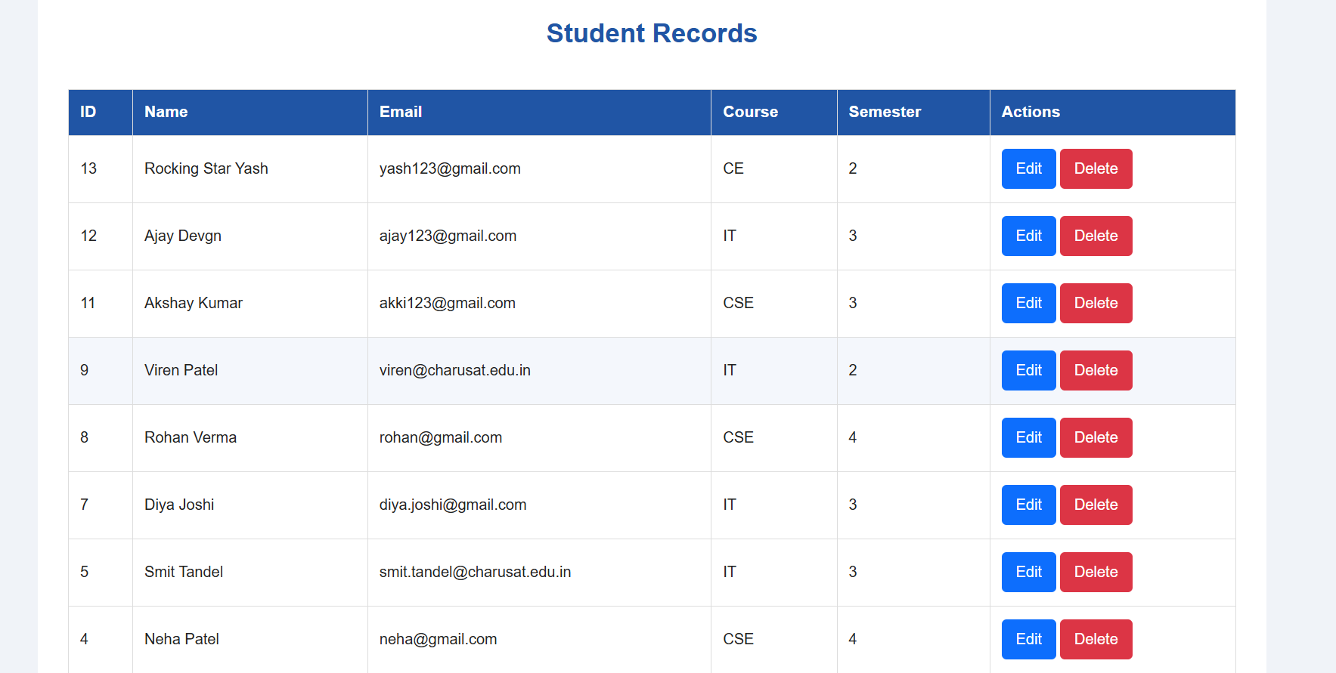
Edit.php:-
<?php
require "db.php";

function h($value) {
return htmlspecialchars((string)$value, ENT_QUOTES, "UTF-8");
}

$id = filter_var($_GET["id"] ?? "", FILTER_VALIDATE_INT);

if (!$id || $id < 1) {
exit("Invalid student ID.");
}

$message = "";
$messageType = "error";

// Update student
if ($_SERVER["REQUEST_METHOD"] === "POST") {
$name = trim($_POST["name"] ?? "");
$email = trim($_POST["email"] ?? "");
$course = trim($_POST["course"] ?? "");
$semester = filter_var(
$_POST["semester"] ?? "",
FILTER_VALIDATE_INT
);

if (
$name === "" ||
!filter_var($email, FILTER_VALIDATE_EMAIL) ||
$course === "" ||
$semester === false ||
$semester < 1 ||
$semester > 12
) {
$message = "Please enter valid student details.";
} else {
try {
$stmt = $conn->prepare(
"UPDATE students
SET name = ?, email = ?, course = ?, semester = ?
WHERE student_id = ?"
);

$stmt->bind_param(
"sssii", $name, $email, $course, $semester, $id
);
$stmt->execute();

$message = "Student updated successfully!";
$messageType = "success";
} catch (mysqli_sql_exception $e) {
error_log($e->getMessage());

$message = $e->getCode() == 1062
? "This email already belongs to another student."
: "Unable to update student.";
}
}
}

// Fetch the current student details
$stmt = $conn->prepare(
"SELECT name, email, course, semester
FROM students WHERE student_id = ?"
);
$stmt->bind_param("i", $id);
$stmt->execute();
$result = $stmt->get_result();
$student = $result->fetch_assoc();

if (!$student) {
exit("Student not found.");
}
?>

<!DOCTYPE html>
<html lang="en">
<head>
<meta charset="UTF-8">
<meta name="viewport" content="width=device-width, initial-scale=1.0">
<title>Edit Student - StudentHub</title>

<style>
body {
font-family: Arial, sans-serif;
background: #f2f5f9;
padding: 20px;
}

.container {
max-width: 500px;
margin: 30px auto;
background: white;
padding: 25px;
border-radius: 10px;
}

h1 { color: #174ea6; }

input {
width: 100%;
padding: 10px;
margin: 10px 0;
box-sizing: border-box;
}

button, a {
display: inline-block;
padding: 10px 14px;
border: none;
border-radius: 4px;
text-decoration: none;
cursor: pointer;
}

button { background: #198754; color: white; }
a { background: #555; color: white; }

.success { color: green; }
.error { color: red; }
</style>
</head>
<body>

<div class="container">
<h1>Edit Student</h1>

<?php if ($message !== ""): ?>
<p class="<?= h($messageType) ?>" role="status">
<?= h($message) ?>
</p>
<?php endif; ?>

<form method="POST">
<label for="name">Name</label>
<input id="name" type="text" name="name"
maxlength="100" required
value="<?= h($student["name"]) ?>">

<label for="email">Email</label>
<input id="email" type="email" name="email"
maxlength="100" required
value="<?= h($student["email"]) ?>">

<label for="course">Course</label>
<input id="course" type="text" name="course"
maxlength="50" required
value="<?= h($student["course"]) ?>">

<label for="semester">Semester</label>
<input id="semester" type="number" name="semester"
min="1" max="12" required
value="<?= h($student["semester"]) ?>">

<button type="submit">Update Student</button>
<a href="index.php">Back</a>
</form>
</div>

</body>
</html>
Screenshot:-
Add a student:
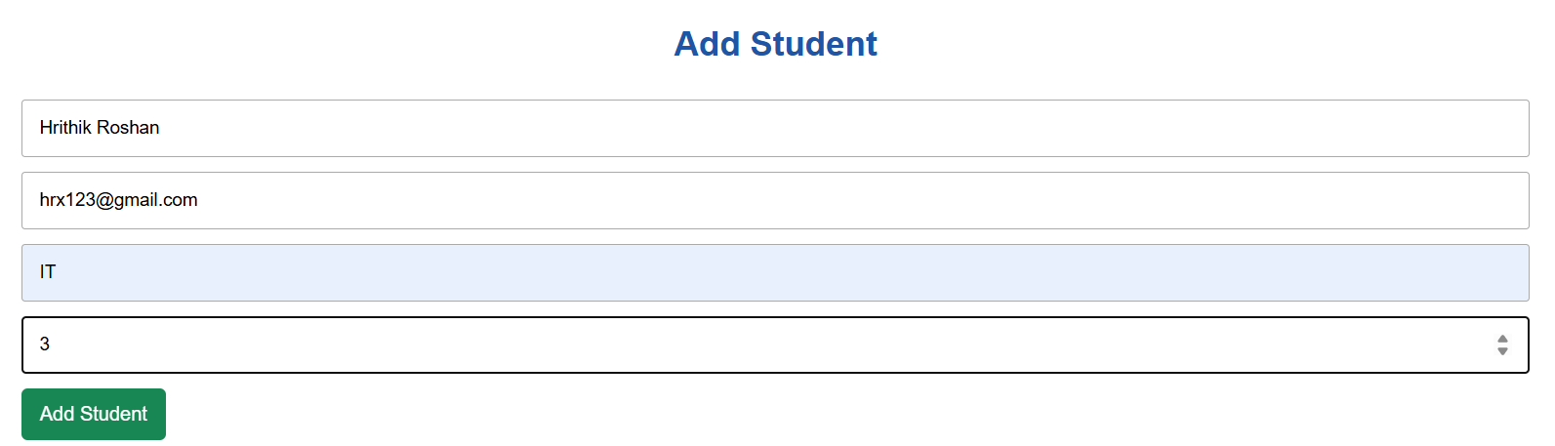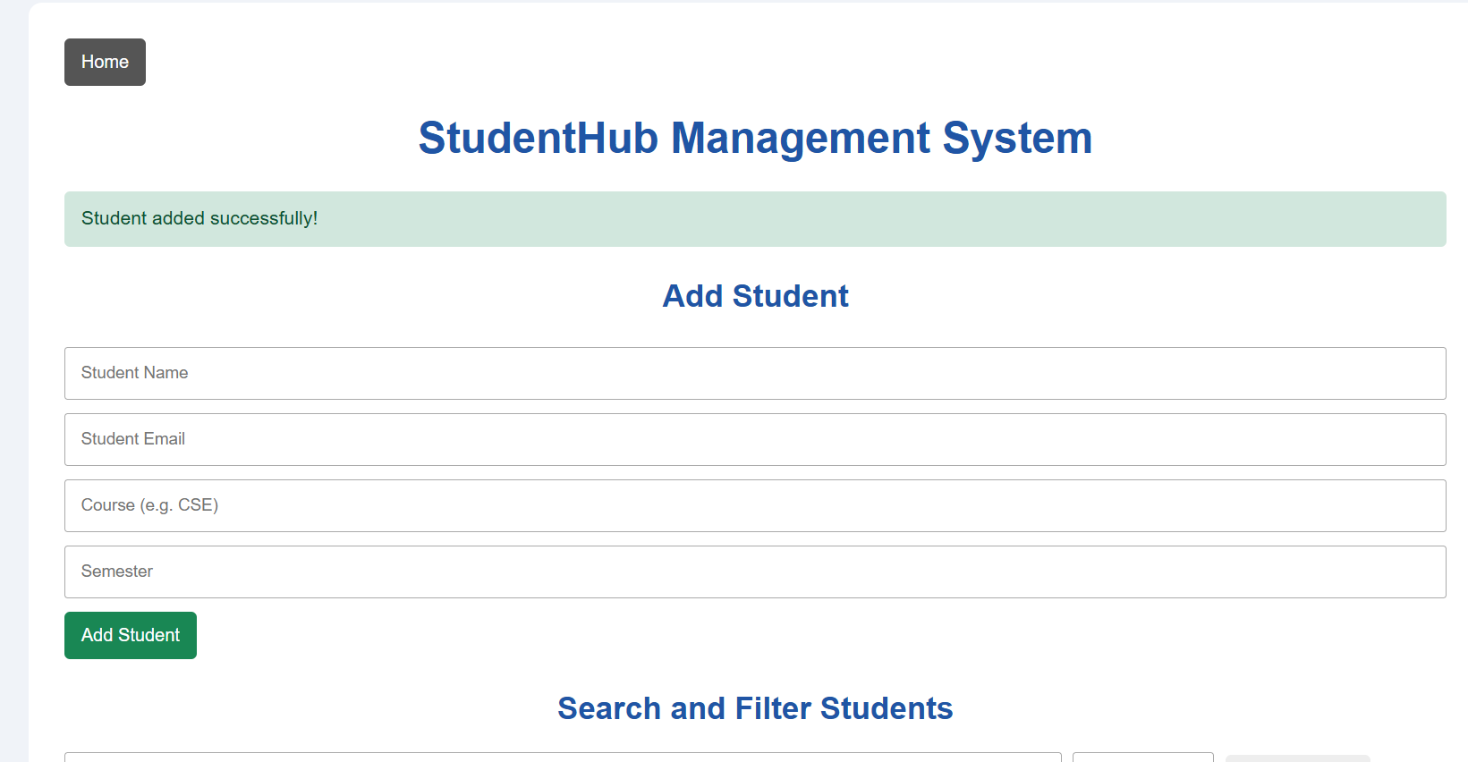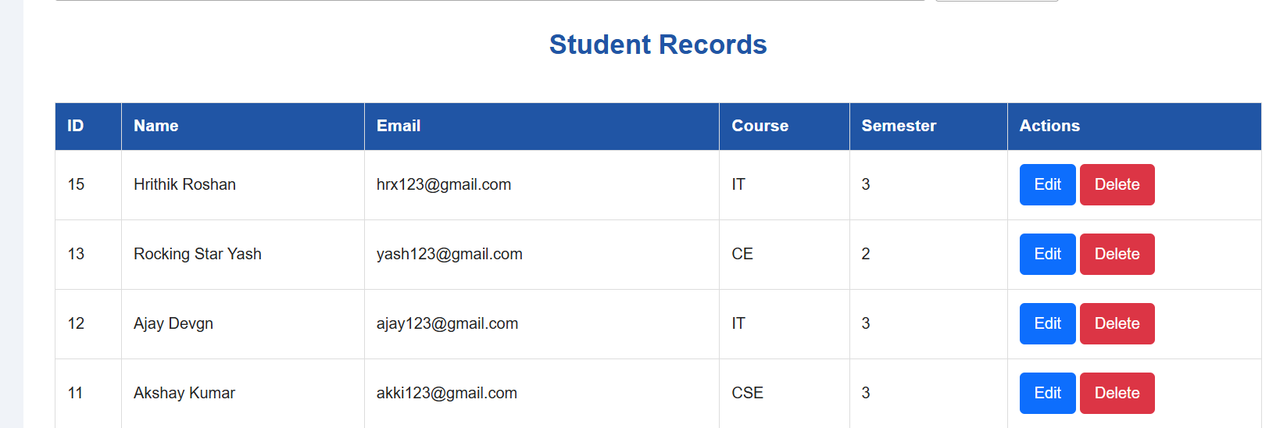
Search a student:-
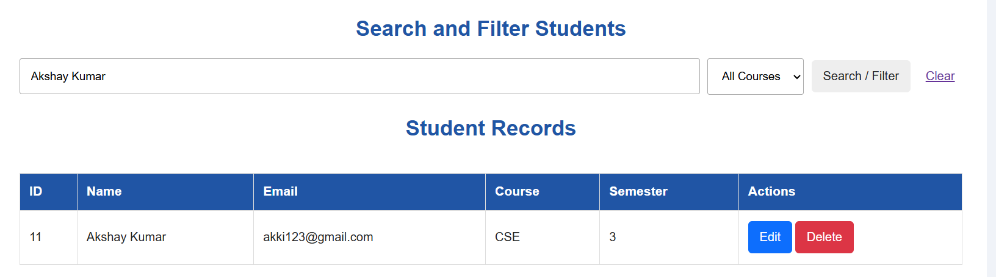
Edit a student detail:-
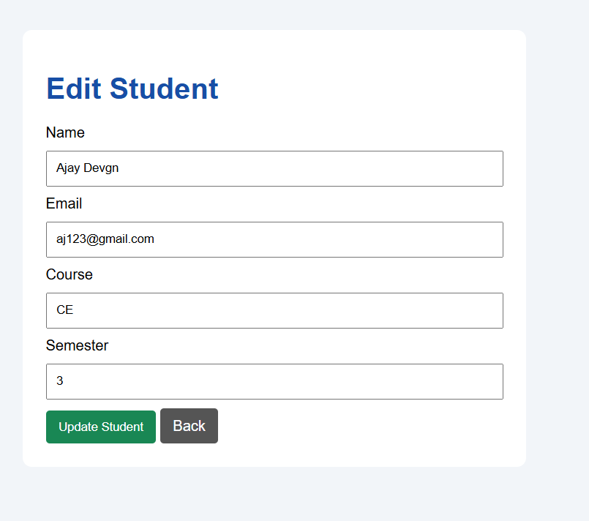
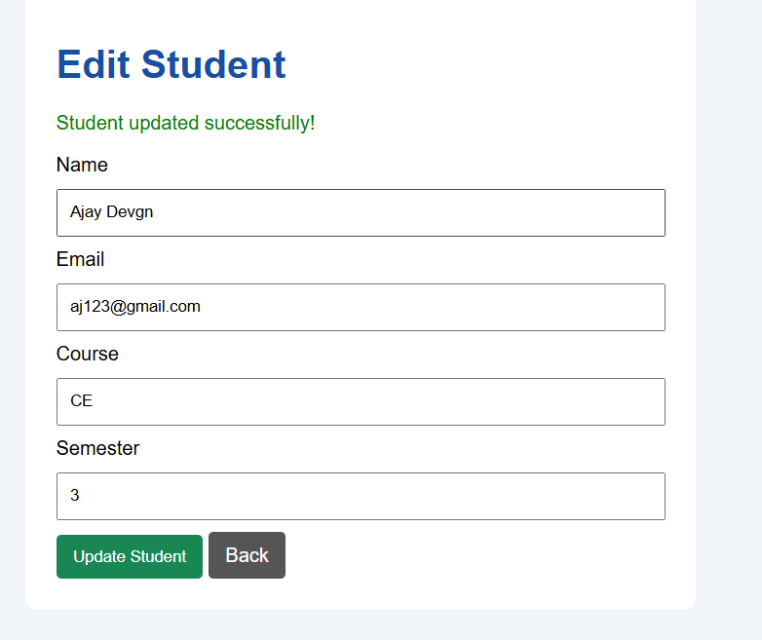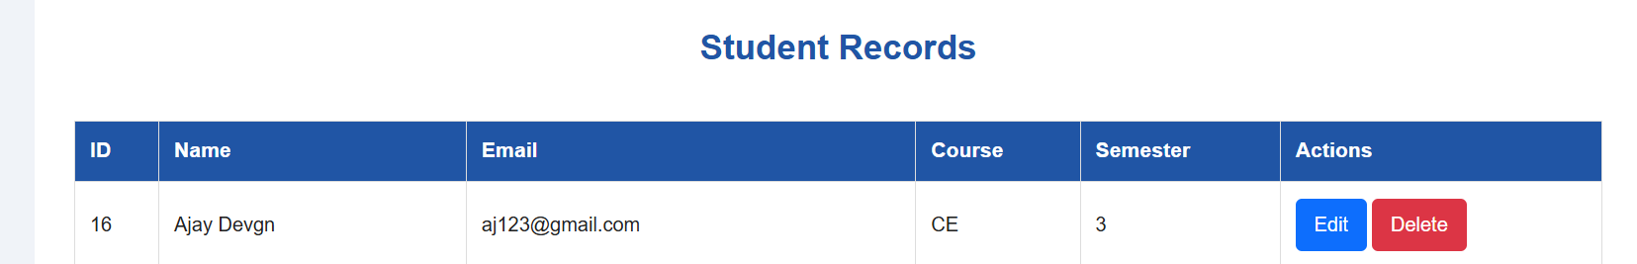
Delete a student:-
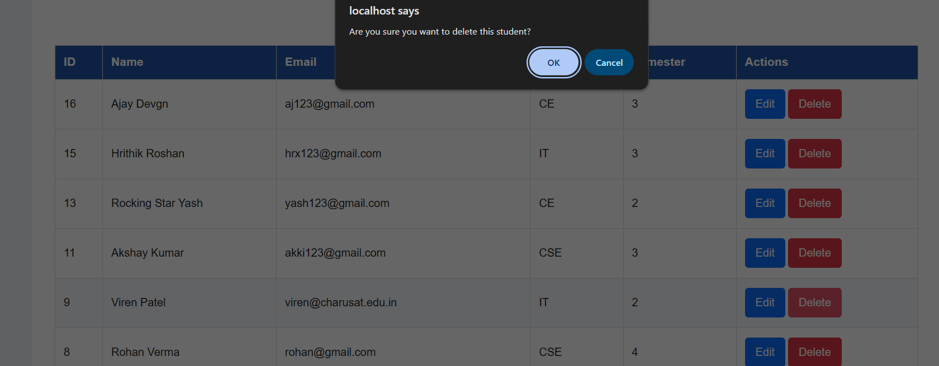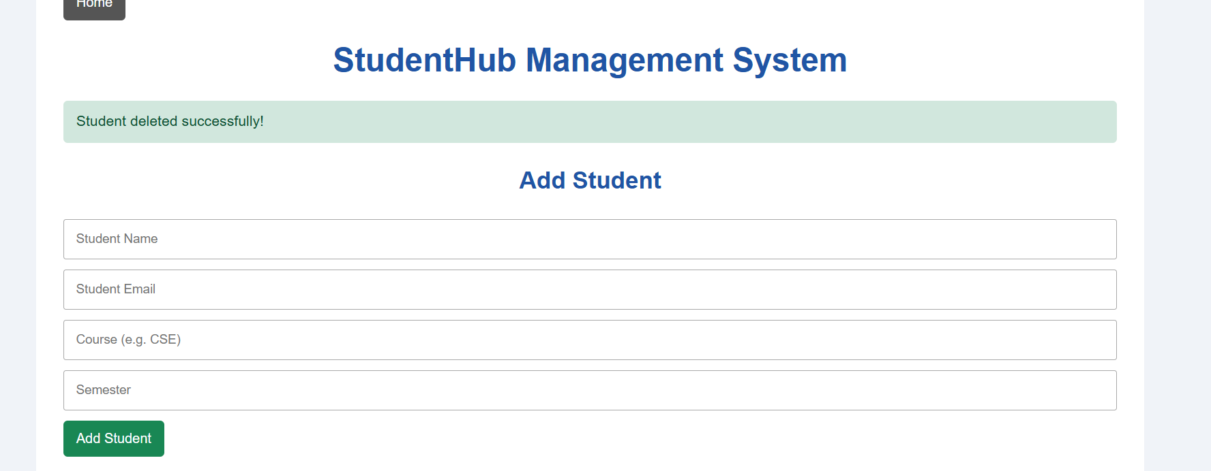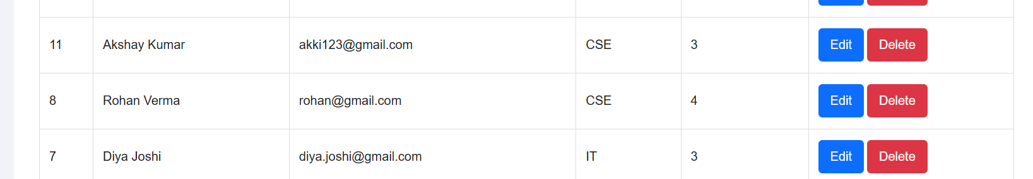
Key Questions / Analysis / Interpretation
1. Are SELECT, INSERT, UPDATE, and DELETE operations working?
Yes. The StudentHub application uses MySQLi prepared statements to perform CRUD operations. INSERT adds student records, SELECT displays records, UPDATE edits existing records, and DELETE removes records.
2. Is search by name/email/course implemented?
Yes. Students can be searched by name or email using the search box. The course dropdown filters records by the selected course. Both search and course filtering can be used together.
3. Are delete operations confirmed before execution?
Yes. A JavaScript confirmation popup appears when the Delete button is clicked. The record is deleted only after the user confirms the action.

